SuccList ={ 'A':['B','C'], 'B':['D','E','F'], 'C':['G','H','I'], 'D':[],'E':[],'F':['J','K'], 'G':[], 'H':[], 'I':['L','M'], 'J':[],
'K':[], 'L':[], 'M':[] }
Start='A'
Goal='C'
Closed = list()
SUCCESS=True
FAILURE=False
State=FAILURE
def GOALTEST(N):
if N == Goal:
return True
else:
return False

def MOVEGEN(N):
New_list=list()
if N in SuccList.keys():
New_list=SuccList[N]
print("New_list=",New_list)
return New_list

def APPEND(L1,L2):
New_list=L1+L2
return New_list

def BFS():
OPEN=[Start]
CLOSED=list()
global State
global Closed
while (len(OPEN) != 0) and (State != SUCCESS):
print("------------")
N= OPEN[0]
print("N=",N)
del OPEN[0] #delete the node we picked
if GOALTEST(N)==True:
State = SUCCESS
CLOSED = APPEND(CLOSED,list(N))
print("CLOSED=",CLOSED)
else:
CLOSED = APPEND(CLOSED,list(N))
print("CLOSED=",CLOSED)
CHILD = MOVEGEN(N)
print("CHILD=",CHILD)
for val in CLOSED:
if val in CHILD:
CHILD.remove(val)
for val in OPEN:
if val in CHILD:
CHILD.remove(val)
OPEN = APPEND(OPEN,CHILD) #append movegen elements to OPEN
print("OPEN=",OPEN)
Closed=CLOSED
return State

#Driver Code
result=BFS() #call search algorithm
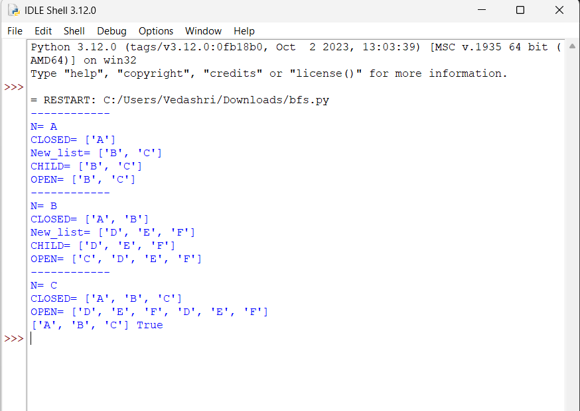
print(Closed,result)

